TEAM NUMBER - PNT2022TMID49391

**Working With**

**Jira**

Creating jira account :

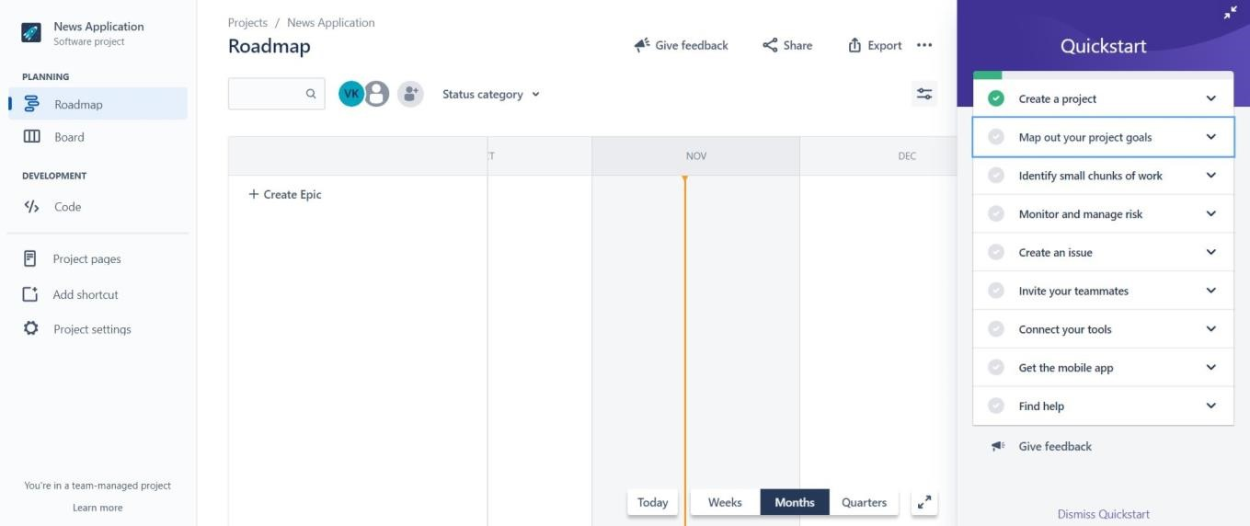

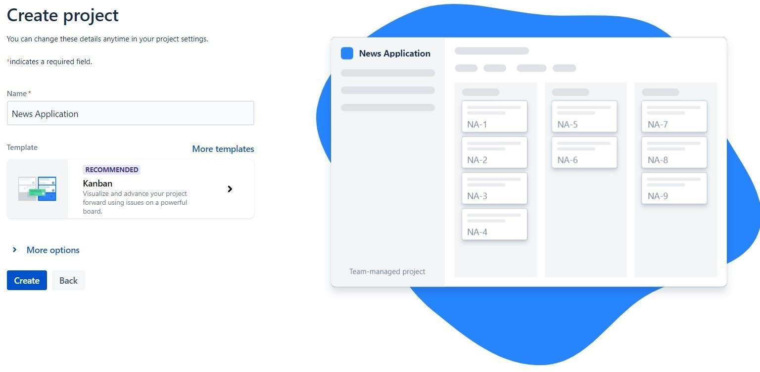

jira account created :

Assigning tasks :

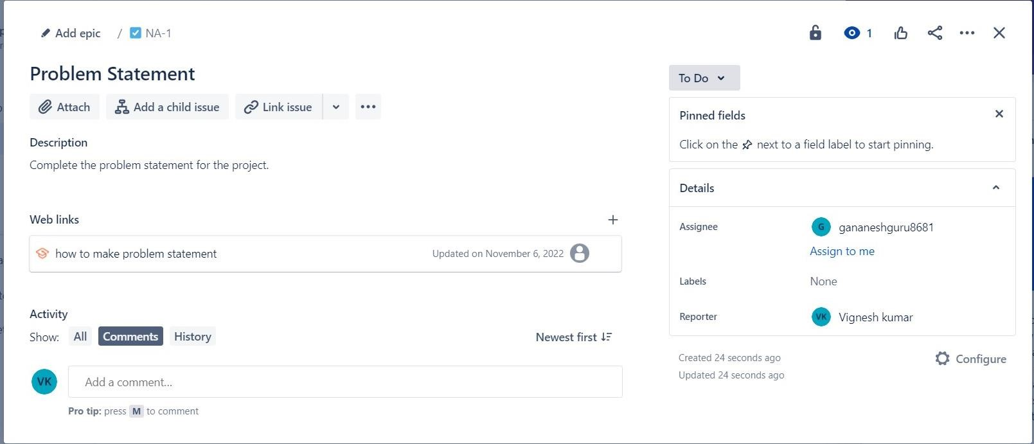

RoadMaps:

